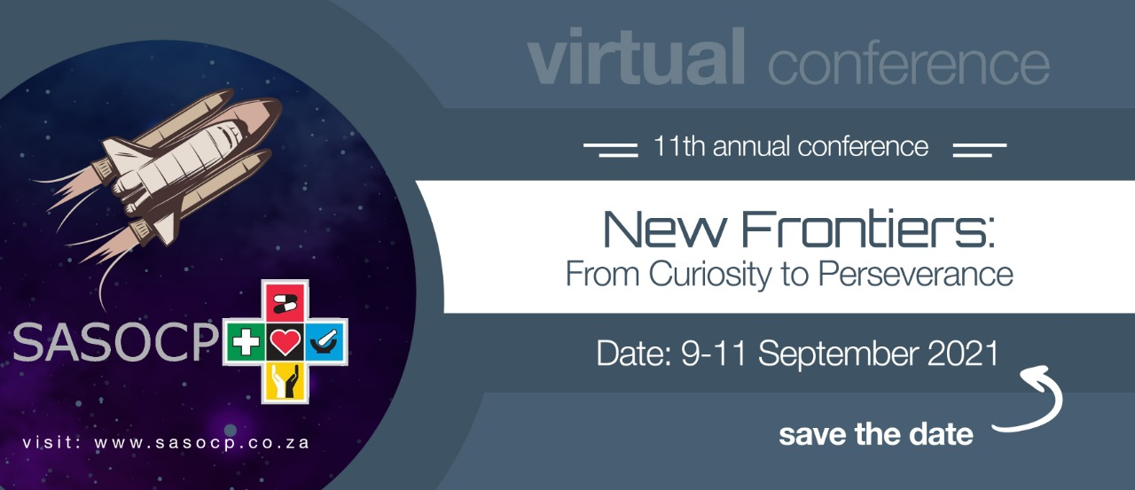

11th Annual Conference of the South African Society of Clinical Pharmacy
9 – 11 September 2021

ABSTRACT SUBMISSION
Please complete and submit via e-mail to: sasocp2021@gmail.com
Submission closes strictly: 15th July 2021

Abstract Submission Guidelines
Abstracts may be submitted for one of three categories: oral-, poster-, or case study presentations. Please indicate your preference (note that the conference committee has the right to change or advise on a different category than originally submitted). Accepted abstracts will be presented during dedicated sessions.
Abstract acceptance/rejection notifications will be sent by the 14th August
Authors are requested to submit abstracts in English. Abstracts must be submitted on the attached ‘abstract submission’ document (Page 3) by email to sasocp2021@gmail.com

Abstracts that do not comply with the following criteria will not be considered for acceptance:
- The abstract should not exceed 350 words (word count includes title, authors, affiliations, spaces, title notes, and footnotes)
- Arial, font size 12 should be used
- Abstract titles should not be longer than two lines and should NOT be in capital letters

All abstracts will be reviewed by an abstract committee. The accepted abstracts will be assigned to appropriate poster-, oral-, or case study sessions. A notification will be emailed to every corresponding author. Authors who then wish to present their abstract at the conference must sent back the signed acceptance document and pay the registration fee. No honorarium, travel-, or accommodation expenses will be provided or covered for presenters.

The theme for the conference is “New Frontiers: from Curiosity to Perseverance”, looking to the future, expanding into new frontiers for clinical practice and excellence in patient care.
Abstracts for poster- and podium presentations should be structured in the following format

Background: A statement of the hypothesis or research question or experience to be described.
Methods: An explanation of the study design and experimental or observational methods used.
Results: A concise summary of the major findings of the experiment, the observation or study. Sufficient data must be provided to permit evaluation by the reviewers and public reading the abstracts. Statements such as "additional information to be presented at the meeting" are not acceptable.
Conclusion: Summary of the overall findings and the relevance to clinical practice.

Presentation Categories
Clinical pharmacy practice encompasses many areas of patient care from pharmacotherapy, medicine supply, antibiotic stewardship and ultimate patient management. The categories covered in this conference aim to be inclusive so as to develop and promote clinical practitioners in pharmacy in South Africa. Please suggest the category you would like to be included in, on the attached abstract form.

Categories:

1. Current clinical practice (such as antibiotic stewardship, paediatrics, critical care, and many more)
2. Educational practices in clinical pharmacy
3. Case study

Case Study Presentation Guidelines
The full case must be submitted as an abstract and if accepted will be published together with all other abstracts in order for attendees to be able to come prepared to the case study presentations. Abstract and presentation should include:
- Why the topic is being presented
- What the problem/issue/challenge was (contextualise this and convey meaning about the importance of resolving the problem. Why was it a priority?)
- What did you do to understand, determine a course of action, communicate, get agreement to and implement the course of action/response to the problem, and how effective was the outcome?
- What did you learn from this problem solving action - about organisation, management, people, systems, managing change, etc.?
- What research did you do to find a solution?
- How it was managed to conclusion/resolution?
- Your role in the process
- What skills have you developed?
- What knowledge have you acquired as a result?
Each case study presentation will be for 15 minutes with an additional 5 minutes for questions.

11th Annual Conference of the South African Society of Clinical Pharmacy
ABSTRACT SUBMISSION - 2021
Presenting Author:
Full Name |  |  |  |  |  |  |  |  |  |  | Title
Surname |  |  |  |  |  |  |  | E-mail address
Fax no. & code |  |  |  |  |  |  | Work tel no. |  | Cell no

Name of Institution or organisation
Co-author(s):

Co-author 1 (title, name, surname)

Co-author 2 (title, name, surname)

Co-author 3 (title, name, surname)
Abstract:

Full title of proposed paper

Two to four key words
Format: please indicate by means of the correct number in the corner block right which category you would like to be considered for. | Category:  POS1 - POSTER: Current clinical practice  POS2 - POSTER: Educational practices in clinical pharmacy  PP1 - PODIUM: Current clinical practice
 | PP2 - PODIUM: Educational practices in clinical pharmacy  CS1 - Case Study |  |  |  |  |  |  |  |  | Place Correct Number Here

Abstract body
INTRODUCTION:

METHODS:

RESULTS:

CONCLUSION:

